Architectural Review Checklist

caCORE SDK
3.2

Revision Document History
Date | Version | Description | Author
09/10/03 | 1.0 | First draft | NCICB Dedicated Support
11/07/03 | 1.0 | Final version 1.0. | NCICB Dedicated Support
05/12/04 | 2.0 | Redesign to incorporate developer answer phase followed by a systems interview phase. | NCICB Dedicated Support
07/09/06 | 3.0 | Filled in the sections | Satish Patel

Table of Contents
1. Introduction 6
1.1 Purpose 6
1.2 Guidelines for Completing the ARC 6
2. Project Details (To be answered by development team) 6
2.1 General Information 6
2.1.1 Project Description 6
2.1.2 Contact Information 6
2.1.3 Major Deployment Milestones 7
2.2 Architectural Details 7
2.2.1 High level architectural description: 7
2.2.2 High Level Design Diagram (If available): 7
2.2.3 Implementation language(s) used? 7
2.2.4 Will connections/requests to the application be session based (i.e. statefull versus stateless)? If so, is there any reason why application would not support “sticky session” load balancing? 7
2.2.5 Will the application be caching data? If so, what is being cached and how much data will be cached? 7
2.2.6 What data files will be created (if any)? How much data will be saved on an on going basis? 8
2.2.7 Will this application need a database schema(s) created on the NCICB infrastructure? If so, what is the maximum number of objects to be stored? 8
2.2.8 Are there any external/non-NCICB data sources that will be accessed by the application? 8
2.2.9 If this is a web-based application, what are the preferred virtual hosts names to be registered? 8
2.2.10 Any additional architectural details that may be of significance to the needed deployment environment. 8
2.3 Performance Requirements 8
2.3.1 Total number of users for this application? 5 8
2.3.2 Peak number of concurrent users? 5 8
2.3.3 Peak number of requests/minute? 20 8
2.3.4 Up time requirements? 14x5 8
2.3.5 Acceptable down time when recovering from major systems disaster? Any 8
2.4 NCICB Project Dependencies 8
2.5 Configuration Management Details 8
2.5.1 Version Control 8
2.5.2 Change Control 8
2.5.3 Migration to CVS 8
2.5.4 Users 9
2.5.5 Build Process 9
2.5.6 Other CM Needs 9
2.6 Additional Notes 9
3. System Requirements (To be answered by both development & systems team) 9
3.1 Operating System 9
Windows 2000/Solaris/Linux 9
3.2 Software (Technology Stack) 9
3.2.1 Web Server: Apache 9
3.2.2 App Server: Tomcat, JBoss 9
3.2.3 Database Server: Oracle, MySQL 9
3.2.4 Other software components: Hibernate, Axis, Spring 9
3.3 Server Hardware 9
3.3.1 Server: <<type, model, …>> 9
3.3.2 Minimum processor speed: 9
3.3.3 Minimum memory: 9
3.3.4 Minimum local drive space: 9
3.4 Storage 10
3.4.1 Expected file server disk storage (in MB):50MB 10
3.4.2 Expected database storage (in MB):50MB 10
3.4.3 Expected ftp storage (in MB):100MB 10
3.4.4 Expected media/image storage (in MB):N/A 10
3.5 Load Balancing/Fault Tolerance 10
3.5.1 Does the application support load balancing? Yes 10
3.5.2 Implement load balancing – NO 10
3.6 Networking 10
3.6.1 Any application specific port assignments? No 10
3.6.2 Any additional configuration? No 10
3.7 Additional Notes 10
4. Proposed NCICB Deployment Environment (To be answered by systems team) 10
4.1 Hardware 10
4.2 Technology Stack 10
4.3 File Server 10
4.4 Database 10
4.5 Networking 10
4.6 Other Resources 10
5. Impact Assessment (To be answered by systems team) 11
5.1 Overview 11
5.2 Cost 11
5.3 Timeline to implement 11
5.4 Additional Notes 11
6. Acceptance 11
7. Appendix 1 - Future Systems Requirements 12
7.1 New Architecture Diagram 12
7.2 Notes on the design change 12
7.3 Hardware 12
7.3.1 Servers 12
7.3.2 Processor speed 12
7.3.3 Memory 12
7.3.4 Drive Space 12
7.4 Software (Technology Stack) 12
7.4.1 Web Server 12
7.4.2 App Server 12
7.4.3 Other components 12
7.5 Fault Tolerance (Redundancy) 12
7.5.1 Does the application support load balancing? 12
7.5.2 Implement load balancing – YES/NO 12
7.5.3 Load balancing requirements 12
7.5.4 Fault tolerance solution suggested 12
7.5.5 Additional requirements (if any) 12
7.6 Performance Enhancements 12
7.6.1 Processing Power 12
7.6.2 Memory 12
7.6.3 I/O 12
7.6.4 Other needs 12

Introduction

Purpose
The purpose of the Architectural Review Checklist (ARC) is to help identify the deployment environment (both hardware and software components) necessary for an application to execute optimally within the NCICB IT infrastructure. The ARC is considered to be a dynamic artifact for any NCICB project and should be maintained in the configuration library (i.e. CVS) for each project. For new projects, this document template will be automatically checked into the projects repository by the SCM team upon project initiation. The ARC should be reviewed on at least a quarterly basis to capture any application design changes that may effect the deployment environment necessary for optimal performance.

Guidelines for Completing the ARC
The ARC is divided into 4 main sections. The first section (Project Details) is meant to capture general information about the project. The project development team should fill out the Project Details section and return it to the systems team. The second section (Systems Requirements) is meant to capture details of specific system requirements for the project. Both the development and system teams will preferably answer the Systems Requirement section jointly. However, depending on the development teams familiarity with the NCICB infrastructure, they may choose to answer either all or parts of this section on their own. The third section (Planned Deployment Environment) specifies the proposed deployment environment for the application and is to be answered by the systems team based on the response to section 1 & 2. Finally, the last section (Impact Assessment) describes the impact (additional hardware/software costs, staffing resources…) to the existing NCICB IT infrastructure in order to support this application. Upon completion of the Deployment Environment and Impact Assessment sections, the systems team will return the ARC to the development team for final review and comments.

Project Details (To be answered by development team)

General Information

Project Description
caCORE SDK is a toolkit to generate “caCORE-like” system from the UML model in the XMI file format. The generated “caCORE-like” system is a n-tier application with various access interfaces like HTTP interface (web interface), web service interface and HTTP tunneling interface. The generated application allows users to access the database using the SDK specific query mechanism.

Contact Information
Title | Name | Phone | Email
Project Manager | Charles Griffin | 301-496-5373 | griffinch@mail.nih.gov
Team Lead/Architect | Satish Patel | 301-451-2229 | patelsat@mail.nih.gov
SCM Coordinator

Major Deployment Milestones
Milestone | Date
Planned Release to QA | N/A
Planned Release to Staging | N/A
Planned Release to Production | N/A

Architectural Details

High level architectural description:
The SDK is a standalone application that runs from the command line and generates an n-tier application. The generated application has three different access mechanisms to the service layer. These access mechanisms are HTTP interface, Webservice interface, HTTP Tunneling interface. The persistence tier is developed using hibernate. Currently it uses connection pool to communicate to either Oracle or MySQL database. In future, container connection pool will be used to access the database.

High Level Design Diagram (If available):
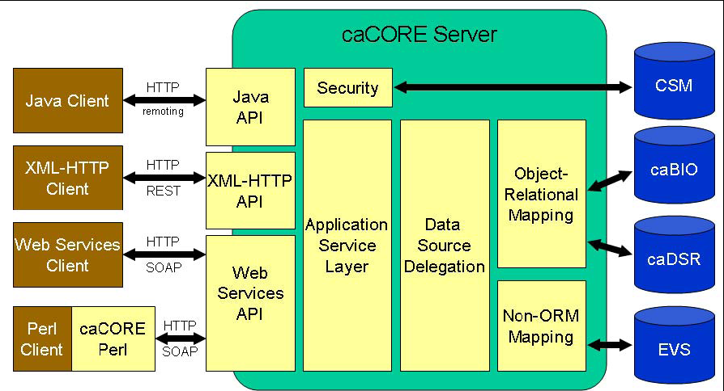

Implementation language(s) used?
Java

Will connections/requests to the application be session based (i.e. statefull versus stateless)? If so, is there any reason why application would not support “sticky session” load balancing?
N/A

Will the application be caching data? If so, what is being cached and how much data will be cached?
Yes, 10MB

What data files will be created (if any)? How much data will be saved on an on going basis?
N/A

Will this application need a database schema(s) created on the NCICB infrastructure? If so, what is the maximum number of objects to be stored?
100

Are there any external/non-NCICB data sources that will be accessed by the application?
N/A

If this is a web-based application, what are the preferred virtual hosts names to be registered?
N/A

Any additional architectural details that may be of significance to the needed deployment environment.

Performance Requirements

Total number of users for this application? 5

Peak number of concurrent users? 5

Peak number of requests/minute? 20

Up time requirements? 14x5

Acceptable down time when recovering from major systems disaster? Any

NCICB Project Dependencies
CSM, CLM,

Configuration Management Details
Briefly describe your current configuration management practices here.

Version Control
What version control software are you currently using, if any?
CVS

Change Control
What are your current change control practices? What procedures are in place to determine whether to implement a change request?
Change Control Group determines the changes to be implemented or not

Migration to CVS
Indicate whether you will require SCM support migrating your source code to the NCICB CVS repository.

Users
Provide a list of all developers who require access to your repository modules.
Satish Patel
Charles Griffin
Dan Dumitru

Build Process
Describe your build process here. For example, are you using Ant, Make, or something else?
Ant

Other CM Needs
Describe any other CM needs?
Everyone should have default read access to the cacoresdk module in CVS
Only the specified users should have read/write access to cacoresdk module in CVS
General users should not have read access to cacoresdk/Project folder in CVS

Additional Notes

System Requirements (To be answered by both development & systems team)

Operating System

Windows 2000/Solaris/Linux

Software (Technology Stack)

Web Server: Apache

App Server: Tomcat, JBoss

Database Server: Oracle, MySQL

Other software components: Hibernate, Axis, Spring

Server Hardware

Server: <<type, model, …>>

Minimum processor speed:

Minimum memory:

Minimum local drive space:

Storage

Expected file server disk storage (in MB):50MB

Expected database storage (in MB):50MB

Expected ftp storage (in MB):100MB

Expected media/image storage (in MB):N/A

Load Balancing/Fault Tolerance

Does the application support load balancing? Yes

Implement load balancing – NO

Networking

Any application specific port assignments? No

Any additional configuration? No

Additional Notes
caCORE SDK is a standalone application. The servers will be utilized to test the generated application.

Proposed NCICB Deployment Environment (To be answered by systems team)

Hardware
Dev

Technology Stack
JBoss 4.0.2, Tomcat 5.5.17, Oracle 9i, MySQL 4.1.19

File Server
N/A

Database
CADEV(cbiodb2-d) and cbiovdev5004

Networking
N/A

Other Resources
Need unsecure FTP access to exchange files with customers

Impact Assessment (To be answered by systems team)

Overview

Cost

Timeline to implement

Additional Notes

Acceptance
Project Lead ( ) | Project Coordinator – NCICB ( )
Systems Team | SCM Administrator

Appendix 1 - Future Systems Requirements
In this section, describe any projected future anticipated requirements for your system.

New Architecture Diagram

Notes on the design change

Hardware

Servers

Processor speed

Memory

Drive Space

Software (Technology Stack)

Web Server

App Server

Other components

Fault Tolerance (Redundancy)

Does the application support load balancing?

Implement load balancing – YES/NO

Load balancing requirements

Fault tolerance solution suggested

Additional requirements (if any)

Performance Enhancements

Processing Power

Memory

I/O

Other needs

